Course-Brew User Documentation:  
Coordinator Guide



UI Examples and Explanation

How to:

1. Add instructor:

Select “Add Instructor” from instructor drop-down

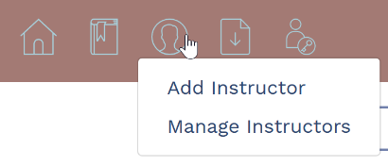

Enter instructor information

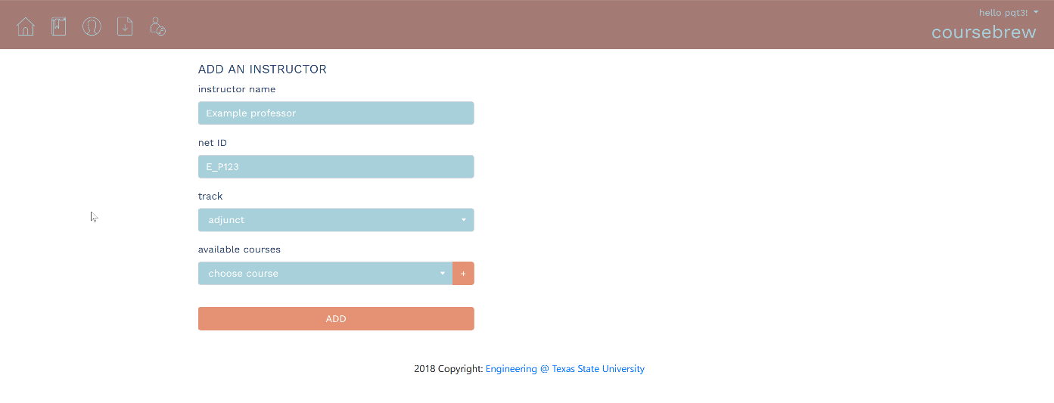

Add available courses from drop-down menu

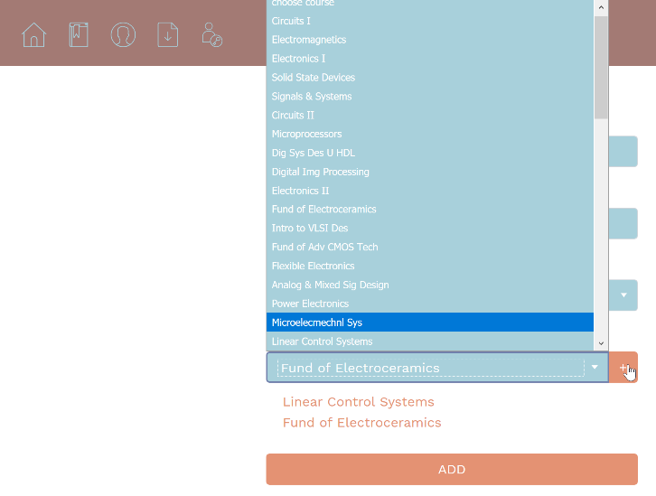

ADD!

1. Edit Instructor:

Select “Manage Instructor” from instructor drop-down

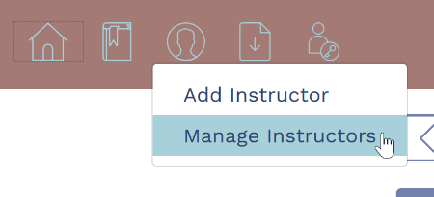

Select specific instructor

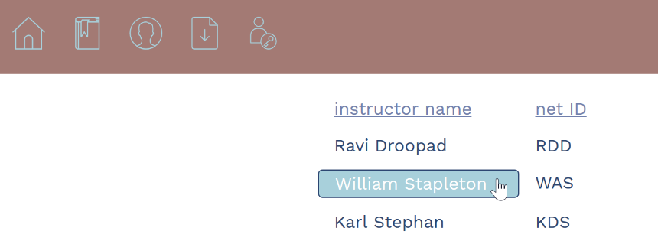

Edit instructor information

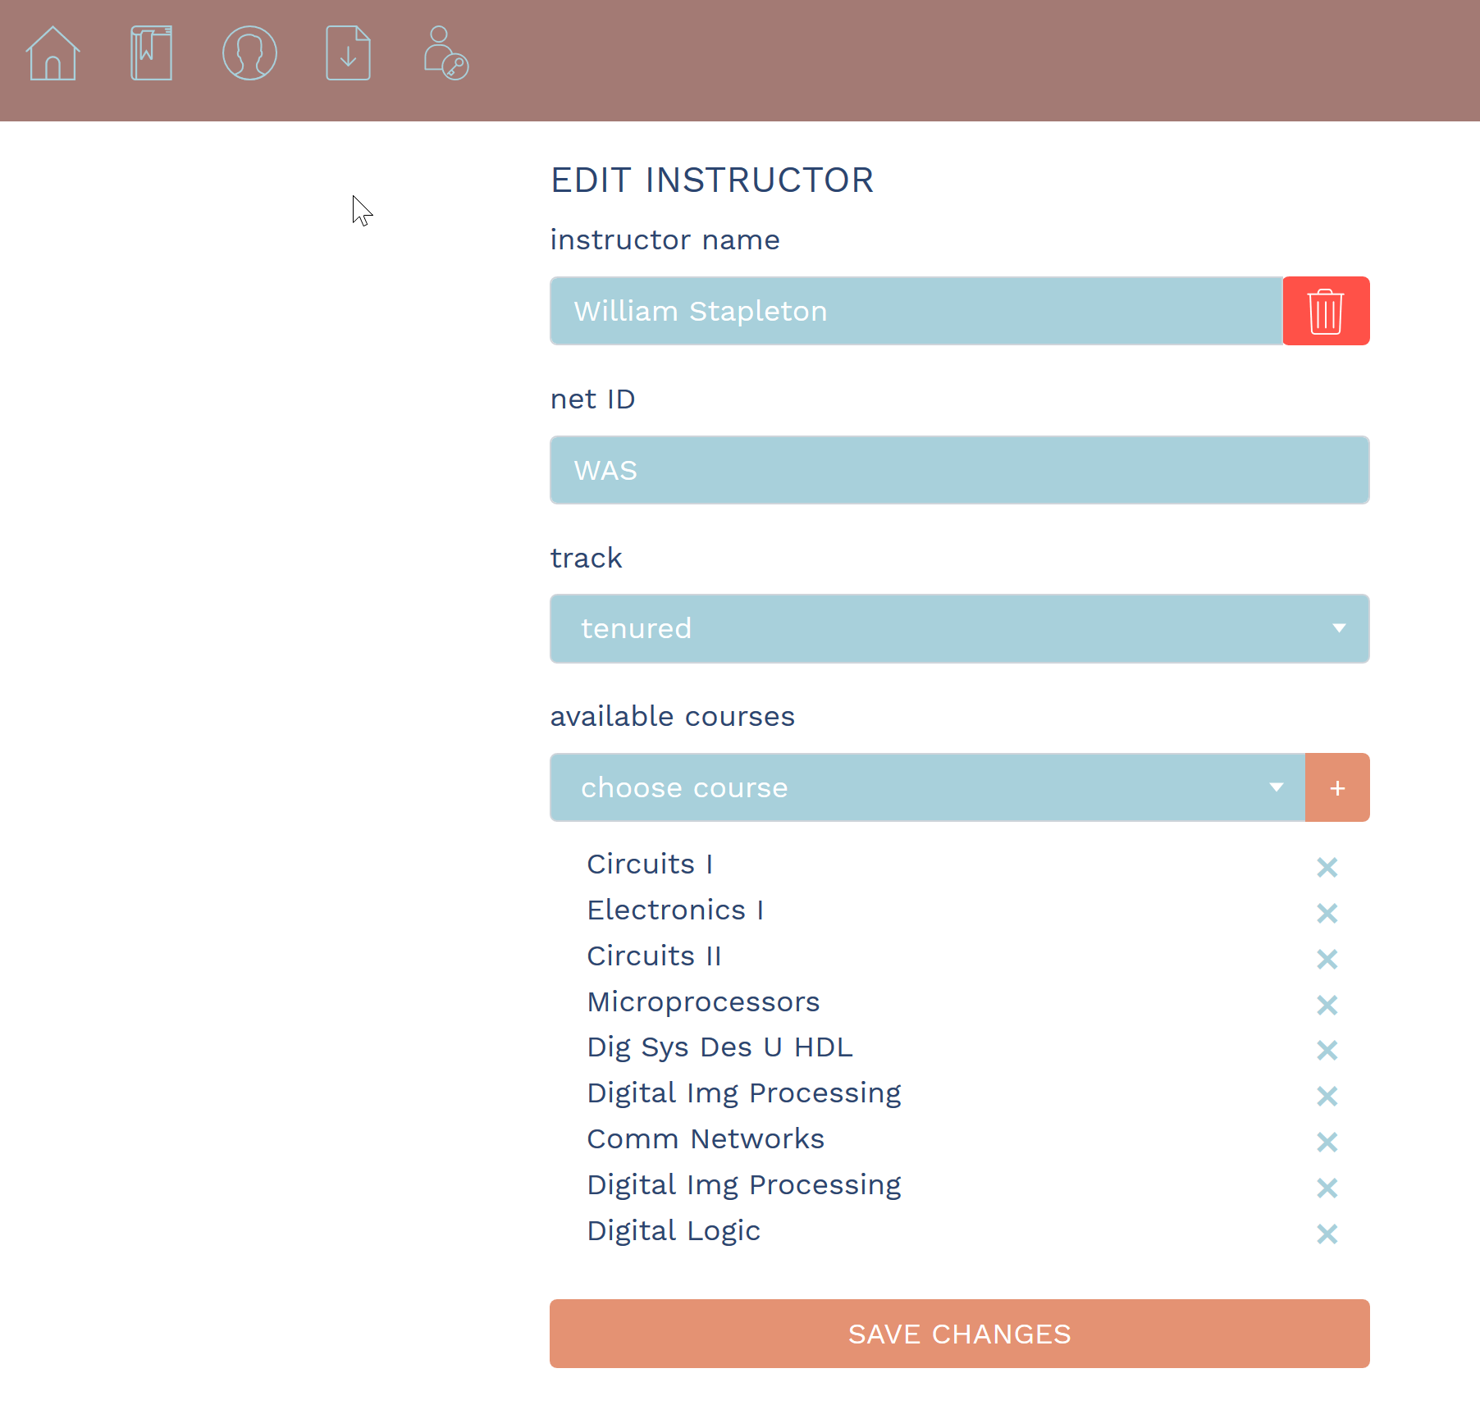

SAVE!

1. Remove Instructor:

Follow edit instructor to select specific instructor

Delete instructor!



1. Add Course:

Select “Add Course” from course drop-down

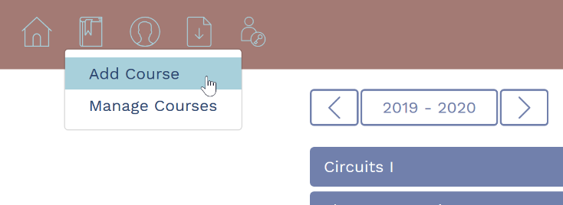

Enter course information

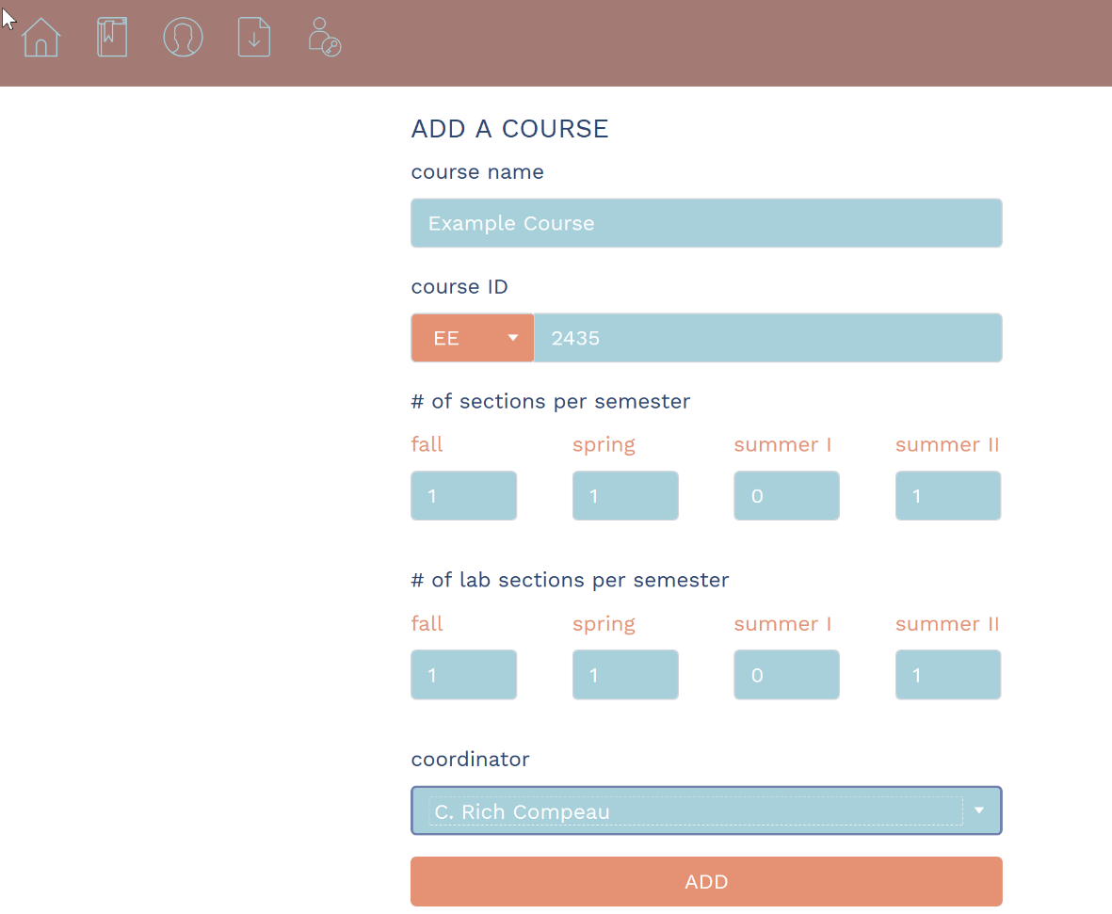

ADD!

1. Edit Course:

Select “Manage Course” from course drop-down

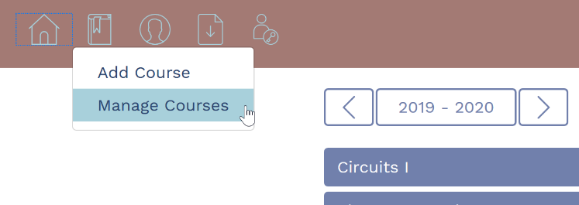

Select specific course

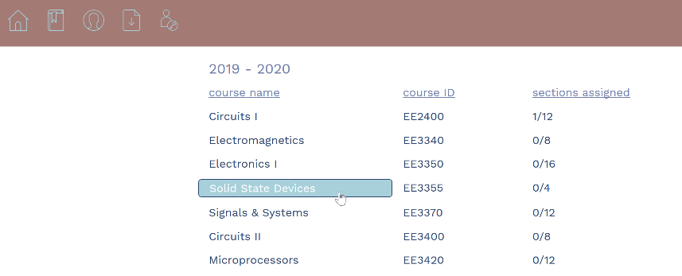

Select “edit course”

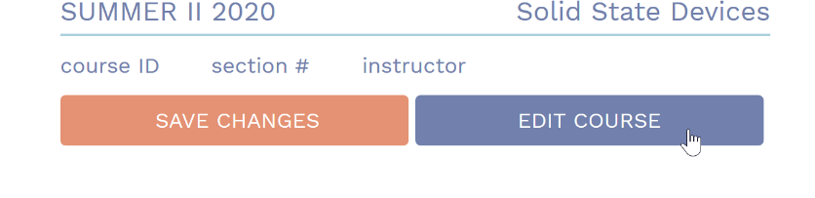

Edit course information

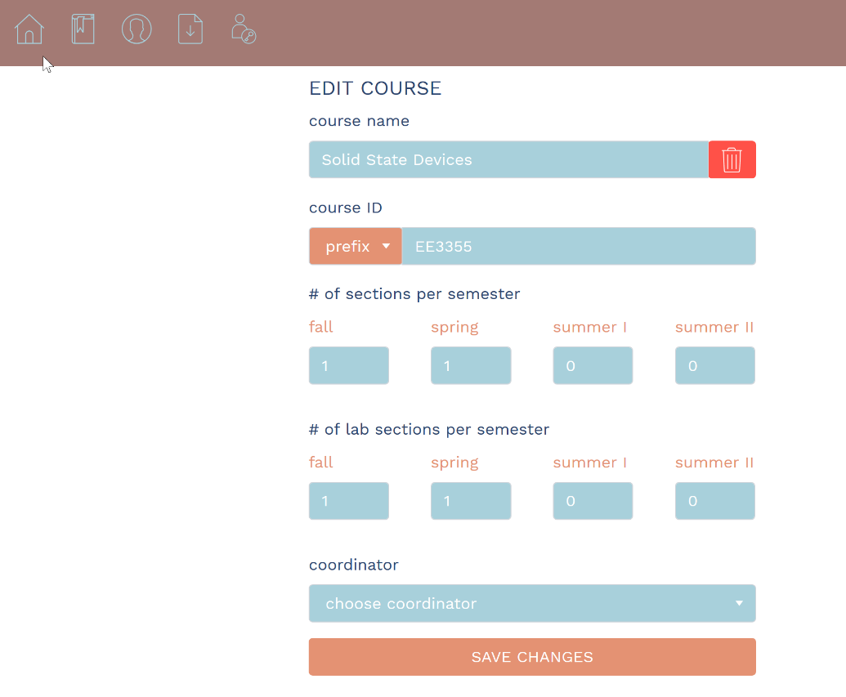

SAVE!

1. Remove Course:

Follow Edit Course instructions to get to edit course page

Delete Course

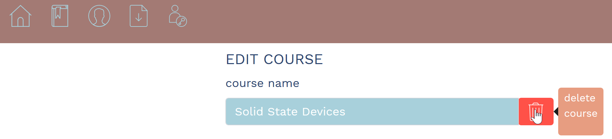

1. Assign a section:

Follow Edit Course instructions to detailed course page

Select section

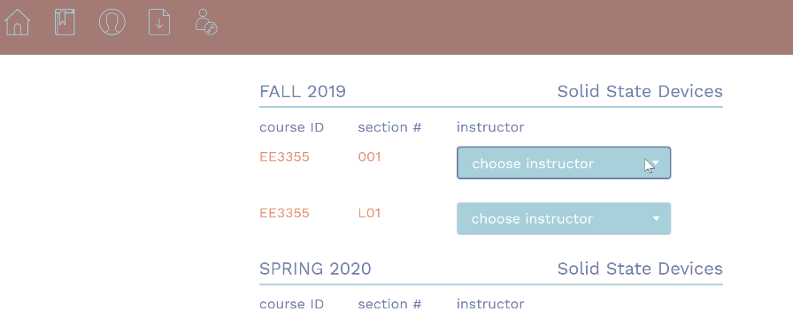

Select instructor from list (top-3 recommended shown at top)

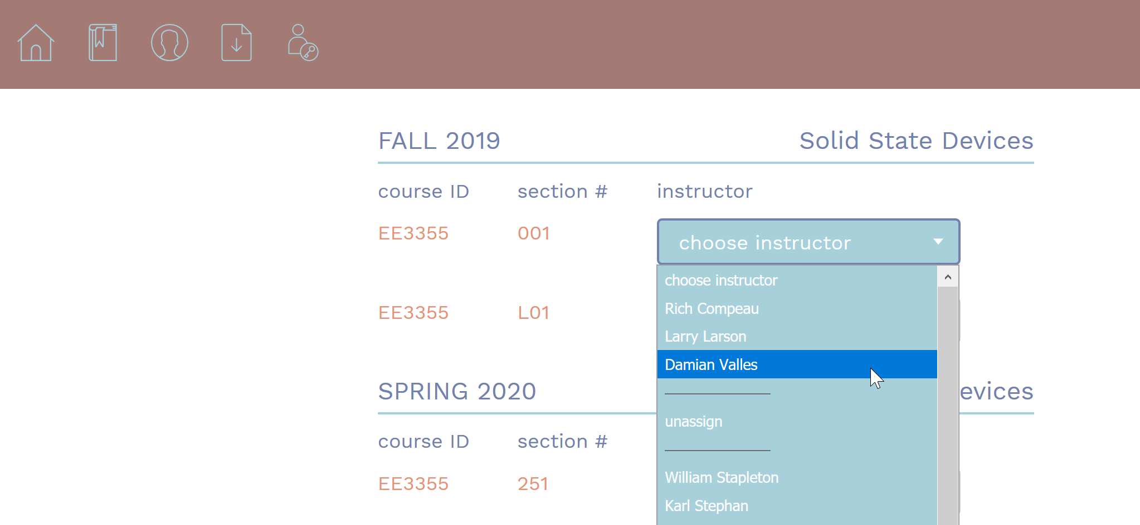

Scrolls to bottom and save changes

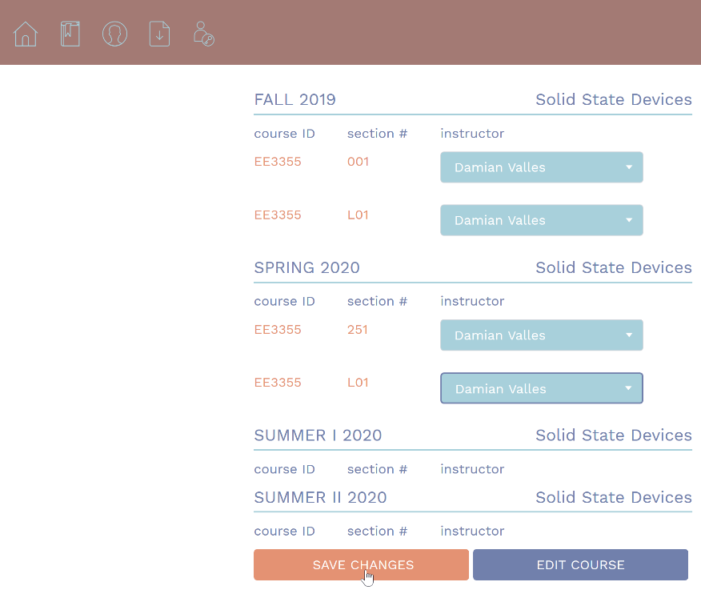

1. Change the Year:

Select Home



Change year



Select whether to copy current assignments into next year or not

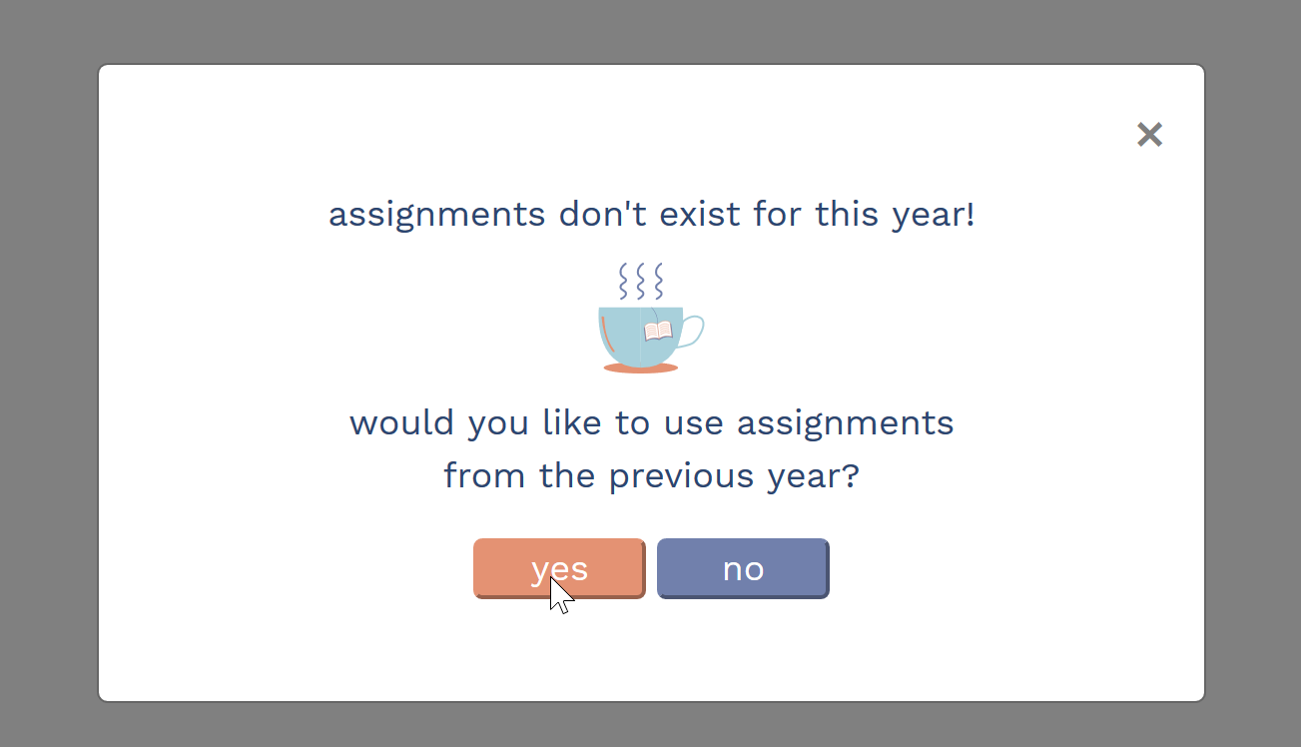

Done!

1. Review Warnings:

Follow Edit Course instructions to detailed course page

Select Warnings

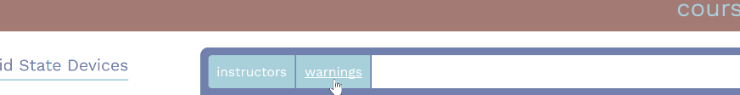

Select Semester

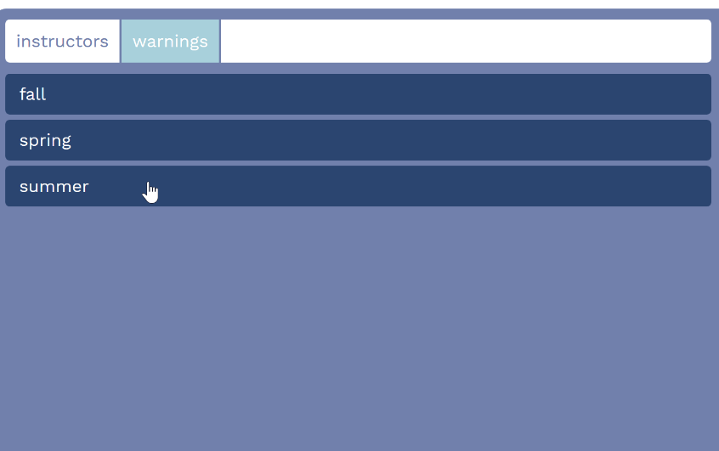

Done!

1. Export Data:

Perform assignments as needed

Export data!

